**Project Development Phase**

**Model Performance Test**

|  |  |
| --- | --- |
| Date | 29 June 2025 |
| Team ID | LTVIP2025TMID47753 |
| Project Name | Visualizing Housing Market Trends: An  Analysis of Sale Prices and Features using Tableau |
| Maximum Marks |  |

**Model Performance Testing:**

Project team shall fill the following information in model performance testing template.

|  |  |  |
| --- | --- | --- |
| **S.No.** | **Parameter** | **Screenshot / Values** |
| 1. | Data Rendered | Data Contains 35 fields 21609 rows |
| 2. | Data Preprocessing | Removed unneccessary columns zipcodes or null values |
| 3. | Utilization of Filters | For Scenario1 |

For S

c

enario2

For

S

c

enario3

For S

c

enario4

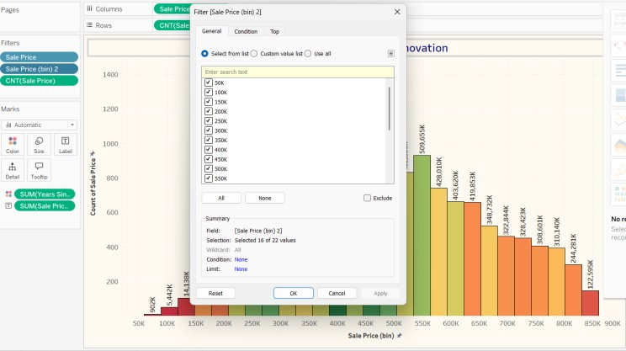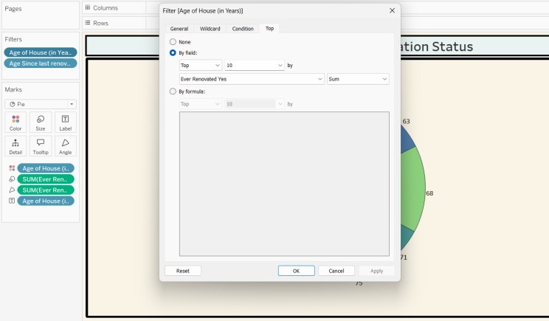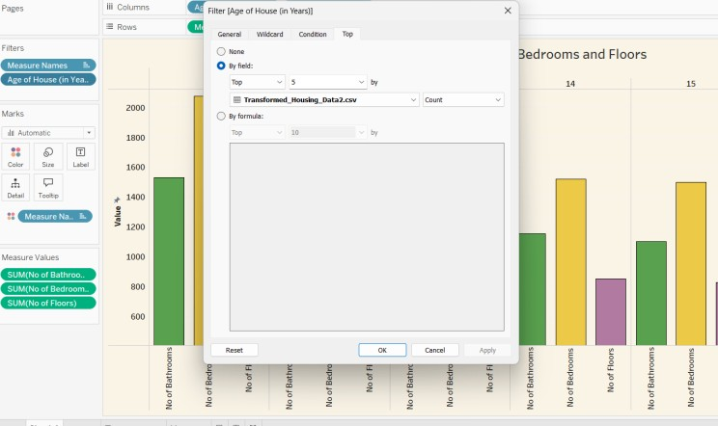

|  |  |  |
| --- | --- | --- |
| 4. | Calculation fields Used |  |
| 5. | Dashboard design | No of Visualizations / Graphs – 4    Dashboard  [https://public.tableau.com/views/dasboard_175128640655](https://public.tableau.com/views/dasboard_17512864065580/Dashboard1?:language=en-US&publish=yes&:sid=&:redirect=auth&:display_count=n&:origin=viz_share_link)  [80/Dashboard1?:language=en-](https://public.tableau.com/views/dasboard_17512864065580/Dashboard1?:language=en-US&publish=yes&:sid=&:redirect=auth&:display_count=n&:origin=viz_share_link)  [US&publish=yes&:sid=&:redirect=auth&:display_count=n&:](https://public.tableau.com/views/dasboard_17512864065580/Dashboard1?:language=en-US&publish=yes&:sid=&:redirect=auth&:display_count=n&:origin=viz_share_link)  [origin=viz_share_link](https://public.tableau.com/views/dasboard_17512864065580/Dashboard1?:language=en-US&publish=yes&:sid=&:redirect=auth&:display_count=n&:origin=viz_share_link) |
| 6 | Story Design | No of Visualizations / Graphs –3    Story  [https://public.tableau.com/views/MyStory_175109223755](https://public.tableau.com/views/MyStory_17510922375570/Story1?:language=en-US&publish=yes&:sid=&:redirect=auth&:display_count=n&:origin=viz_share_link)  [70/Story1?:language=en-](https://public.tableau.com/views/MyStory_17510922375570/Story1?:language=en-US&publish=yes&:sid=&:redirect=auth&:display_count=n&:origin=viz_share_link)  [US&publish=yes&:sid=&:redirect=auth&:display_count=n&:](https://public.tableau.com/views/MyStory_17510922375570/Story1?:language=en-US&publish=yes&:sid=&:redirect=auth&:display_count=n&:origin=viz_share_link)  [origin=viz_share_link](https://public.tableau.com/views/MyStory_17510922375570/Story1?:language=en-US&publish=yes&:sid=&:redirect=auth&:display_count=n&:origin=viz_share_link) |